INDUSTRY PROBLEM SOLVING TASK
CO4_AT2 — Assignment
Name: Madhu Balan I
Reg no: 192321142
Course: Computer Vision

1. Autonomous Vehicle Vision System Selection
Industry context: An automobile company is developing an autonomous vehicle detection system. The system must achieve at least 90% accuracy, must not exceed 70 ms latency, and must operate with moderate computational resources.
Method | Accuracy | Latency | Computation | Accuracy ≥ 90%? | Latency ≤ 70 ms?
Viola-Jones | 82% | 30 ms | Low | No | Yes
YOLO | 93% | 60 ms | Moderate | Yes | Yes
Deep Learning | 97% | 90 ms | High | Yes | No

Question: Compare the three methods and evaluate which method satisfies all the constraints. Justify your decision using logical reasoning based on accuracy, latency, and computational requirements.
Answer:

The first step is to treat the requirements as hard constraints rather than preferences. The selected method must pass all three tests: accuracy must be at least 90%, latency must be no more than 70 ms, and the computational demand must be compatible with moderate hardware. A method that fails even one of these conditions cannot be selected as the primary system under the stated specification.
Viola-Jones has the lowest latency at 30 ms and requires low computation, so it would be easy to deploy on an economical embedded platform. However, its accuracy is only 82%, which is below the required 90% threshold. Because an autonomous vehicle must detect vehicles, pedestrians, obstacles, and other road users reliably, this failure is decisive. Viola-Jones is fast enough, but it does not satisfy the safety-related accuracy requirement.
Deep Learning achieves the highest accuracy at 97%, but its latency is 90 ms, exceeding the maximum permitted 70 ms by 20 ms. It also requires high computation, whereas the vehicle supports only moderate computational resources. Even though its recognition quality is excellent, the delayed response could reduce the time available for braking, steering, or collision avoidance. Therefore, Deep Learning fails both the latency and hardware constraints for this particular deployment.
YOLO achieves 93% accuracy, which is above the 90% minimum, and 60 ms latency, which is below the 70 ms maximum. Its computational requirement is moderate and therefore matches the available vehicle hardware. YOLO is the only method that passes every constraint simultaneously. It provides a 3-percentage-point accuracy margin and a 10 ms latency margin, giving the system some tolerance for normal variation in workload or operating conditions.
The recommended choice is therefore YOLO. The decision is not based simply on the highest accuracy; it follows from constraint satisfaction. Viola-Jones fails accuracy, while Deep Learning fails latency and computation. YOLO meets accuracy, response-time, and resource requirements at the same time, making it the most logical and practical method for the autonomous vehicle system.
Before production deployment, the company should still test YOLO under night driving, rain, glare, dense traffic, camera vibration, and different processor loads. If the measured latency occasionally exceeds 70 ms, the model could be optimised through image resizing, quantisation, pruning, hardware acceleration, or a carefully designed region-of-interest pipeline. These optimisations should be validated without reducing accuracy below the required threshold.
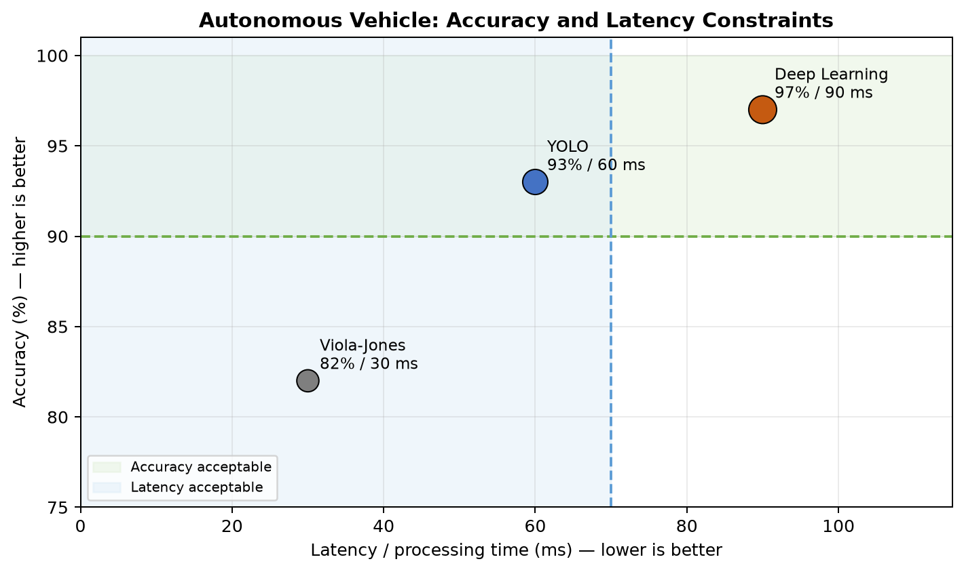
Figure 1. The shaded regions show the accuracy and latency requirements. YOLO is the only method inside both acceptable regions while also matching moderate computation.

2. Smart Factory Product Inspection Selection
Industry context: A manufacturing company wants a real-time computer-vision inspection system to identify defective products on a production line. The system must achieve at least 95% accuracy, must process each item within 50 ms, and must run on hardware that supports moderate computation.
Method | Accuracy | Processing time | Computation | Accuracy ≥ 95%? | Time ≤ 50 ms?
Traditional Image Analysis | 91% | 25 ms | Low | No | Yes
YOLO | 96% | 45 ms | Moderate | Yes | Yes
Deep Learning | 98% | 75 ms | High | Yes | No

Question: Compare the three methods and evaluate which method satisfies all the constraints. Justify your decision using logical reasoning based on accuracy, processing time, and computational requirements.
Answer:

The production-line requirements are strict because both missed defects and excessive processing time can create operational problems. An accuracy below 95% could allow defective items to pass to customers, while processing above 50 ms could slow the conveyor, create a queue of unprocessed products, or require the line speed to be reduced. Therefore, the chosen method must pass the accuracy, processing-time, and hardware conditions together.
Traditional Image Analysis is efficient, with a processing time of only 25 ms and low computational demand. It may work well when products have fixed positions, consistent lighting, simple shapes, and predictable defects. However, its 91% accuracy is below the required 95%. The 4-percentage-point shortfall means the method cannot be accepted as the primary inspection solution under the stated quality requirement, even though it is fast and inexpensive.
Deep Learning provides the highest accuracy at 98%, which would be attractive for detecting small, irregular, or previously unseen defects. However, its 75 ms processing time is 25 ms above the 50 ms limit. Its high computational requirement also exceeds the moderate hardware available. If used without optimisation, it could interrupt the production rhythm or require expensive hardware upgrades. It therefore fails the real-time and resource constraints.
YOLO achieves 96% accuracy, exceeding the minimum by 1 percentage point, and processes an item in 45 ms, leaving a 5 ms margin below the maximum allowed time. Its moderate computation matches the available hardware. YOLO is consequently the only method that satisfies every stated constraint and is the recommended option.
The small margins should still be treated carefully. A 5 ms processing margin may disappear when the factory system handles multiple cameras, high-resolution images, network traffic, or additional software tasks. The company should measure end-to-end latency rather than only model inference time. It should also validate performance across product batches, surface materials, lighting changes, camera vibration, and all known defect categories.
If additional reliability is required, YOLO could be supported by controlled lighting, camera calibration, a reject-confirmation stage, and periodic quality audits. The factory could also reserve Deep Learning for offline analysis or difficult cases while allowing YOLO to perform the main real-time screening. However, for the single-method choice described in the task, YOLO is the correct selection because it meets accuracy, speed, and computation requirements simultaneously.
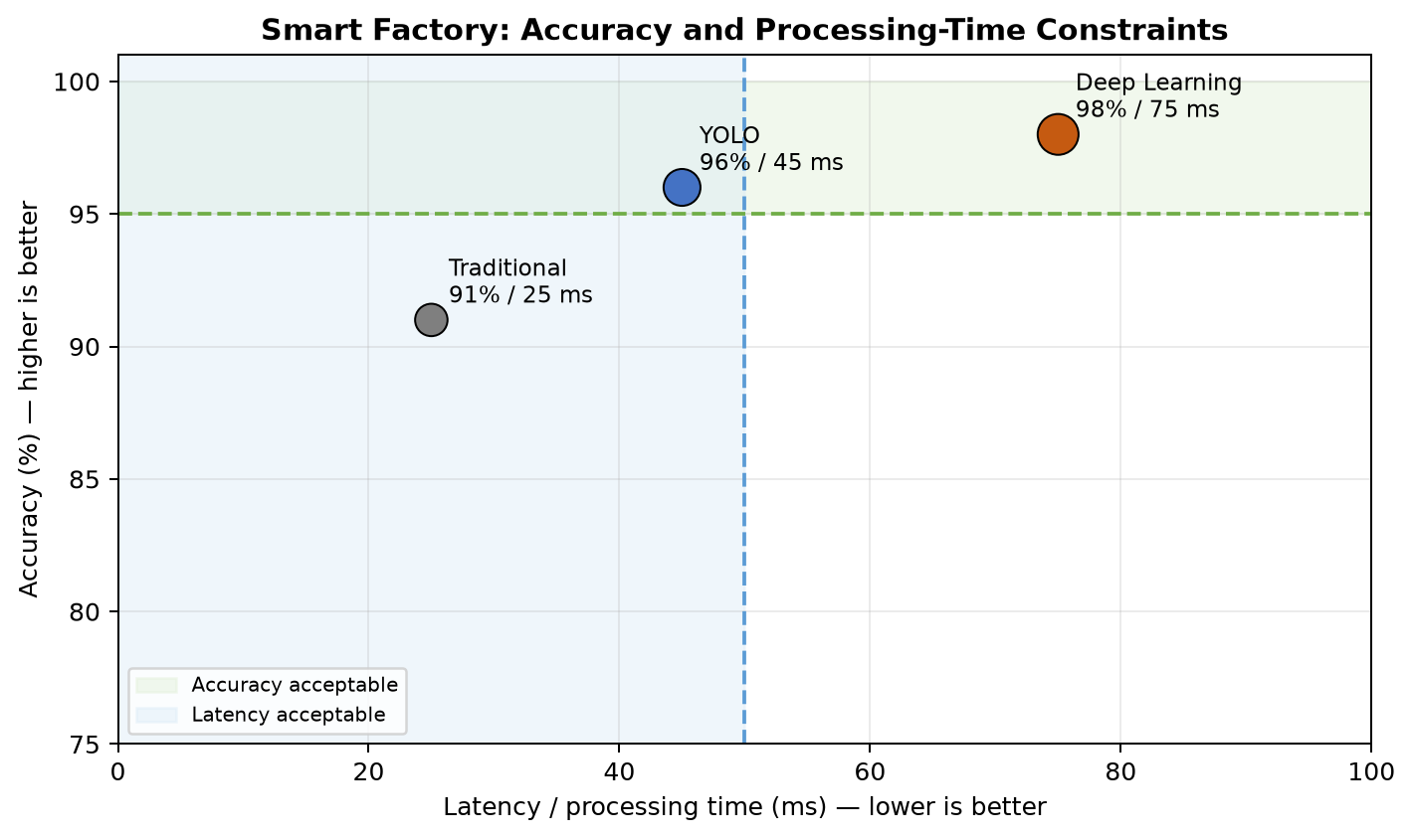
Figure 2. The shaded regions show the factory accuracy and processing-time requirements. YOLO is the only method that satisfies both constraints while remaining within moderate computation.

